SPIRIT UNBOUNDED, Winging her Way 11
Human Rights in the Emerging Catholic Church 10th December 2023


"There is no longer Jew or Greek, there is no longer slave or free, there is no longer male and female; for all of you are one in Christ Jesus."
Galatians 3:28



Universal Declaration of Human Rights
Today is the 75th Anniversary of the Universal Declaration of Human Rights, which enshrines our rights as human beings to be treated equally, regardless of gender, ethnicity, religion, or sexuality.
This statement also encapsulates everything that Spirit Unbounded stands for, upholding our rights, not only as part of the human family, but as disciples of Jesus Christ. As Jesus said:
"If you abide in my word, you are truly my disciples, and you will know the truth, and the truth will set you free." John 8:31-32

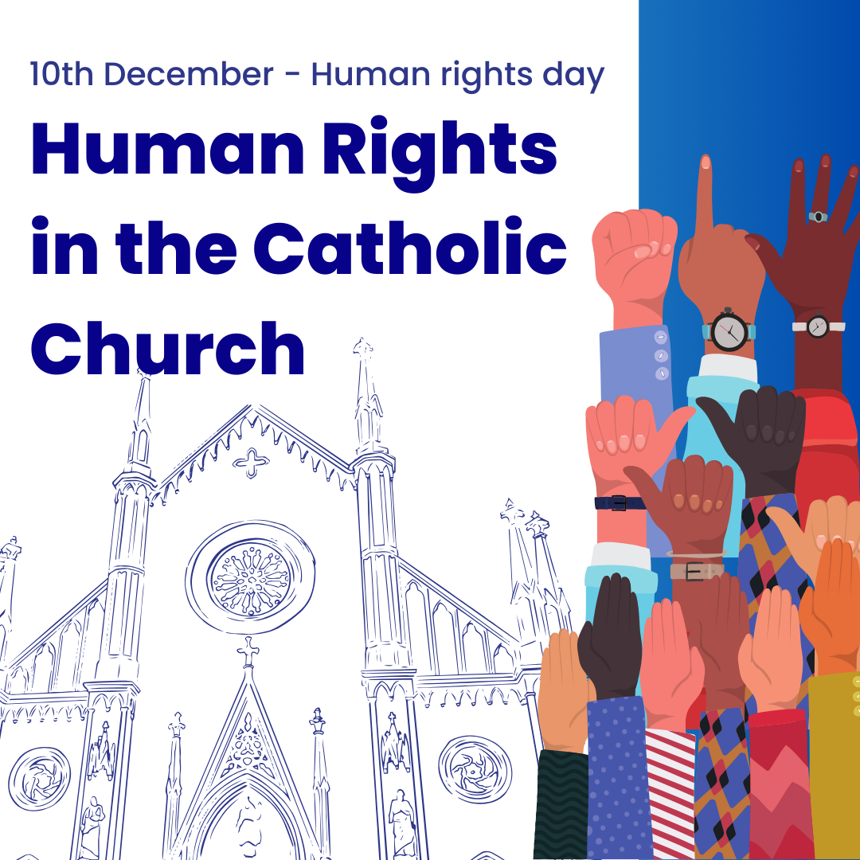
A humorous take on the Catholic Church and Human Rights
Get ready to blow out the candles on the 75th birthday cake of the Universal Declaration of Human Rights (UDHR) this December! 🎂 International Human Rights Day, celebrated on December 10th each year, marks this epic milestone in the quest for world peace, justice, and sustainable development. It's like the global birthday party for everyone's inalienable rights.
But hold on to your mitres! The Holy See, the big cheese in the Catholic Church, isn't exactly RSVPing to all of the Human Rights Conventions approved by the United Nations (UN). Despite having a VIP seat at the UN table, the Holy See has been a bit picky about adopting and ratifying these conventions. Catholics might be scratching their heads, wondering what the Holy See's deal is at the UN. Find out about it here.
Now, onto some holy controversy! The Holy See has given a holy nod to some international treaties but took some criticism for not getting on board with others. For instance, they're not accepting the Convention on the Elimination of All Forms of Discrimination against Women (CEDAW) and haven't fully embraced the Convention on the Rights of the Child (CRC). Why the cold shoulder? Turns out, it's because these conventions might step on the toes of certain church teachings that are looking a bit outdated. Historians Helen Bond and Joan Taylor spill the holy tea on this.
Let's dive into the holy hotspots of tension:
- Freedom of Conversion: Changing religions? The UDHR is all for it, but not the Catholic Church - if you’re leaving the party! – they’ll not be handing out permission slips any time soon.
- Women's Rights: The Catholic Church's take on women's roles doesn't exactly sync with the gender equality proclaimed in the UDHR. Ban on women's ordination? That's a no-go for some critics – misogyny’s the only party in town for some party-goers.
- LGBTQ+ Rights: The Church's conservative stance on sexual orientation clashes with the UDHR's anti-discrimination playlist.
- Reproductive Rights: Contraception and abortion are touchy subjects where church doctrine meets UDHR recognition.
Now, for the grand finale! The Holy See's reluctance to go all-in on the UDHR is like trying to keep control of the remote. It's a power move, protecting the patriarchy and hanging on to tradition. Add in some clericalism, hierarchical hurdles, and a sprinkle of historical and contemporary scandals, and you've got the Holy See doing the limbo under the bar of human rights standards.
Professor Mary McAleese, the two-term, ex-president of Ireland, isn't mincing words. In a keynote address, she's calling out the Church for clinging to its outdated handbook. She's saying, "Come on, Church, get with the times!" The biggest Christian Church in the world, the heavyweight champ NGO, and the only faith with UN VIP status are in a credibility crisis because they forgot to update the rulebook. Time for a Church glow-up, perhaps?
So, will the Holy See blow out the candles and make a wish for a more just and non-discriminatory church and human rights-friendly future? Only time will tell in this holy drama! It's not just a birthday party—it's a wake-up call for the Church to step into the 21st century.🕊️✨
If you want to read more, here is another article hosted on our new blog.
Maggie Conway (Co-Founder Spirit Unbounded)


The effort to phase out fossil fuels took a leap forward at Cop28, with the decision of Colombia to formally endorse the call for a Fossil Fuel Non-Proliferation Treaty.
Colombia will be the largest fossil fuel producer to date to endorse this treaty, which also has the support of The Vatican and the Laudato Si movement.
Thanks to Michael Poland of The Fossil Fuel Non-Proliferation Treaty Initiative for keeping us updated about this exciting news.
https://fossilfueltreaty.org/
However the Saudi delegation has vetoed all mention of fossil fuels in any deal coming out of COP28 which could mean the end of progress. Prayers please.

